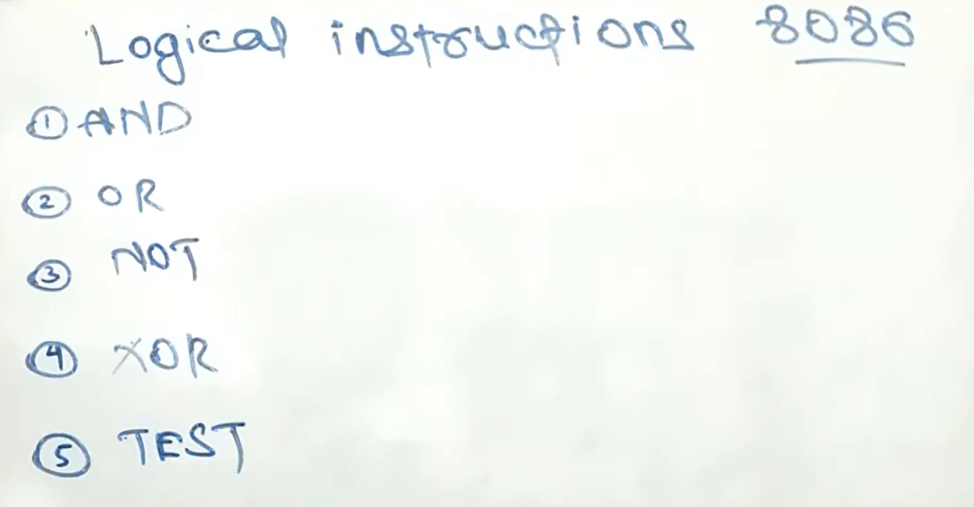

**NOT** is the only bitwise logical instruction that doesn’t affect any flag.

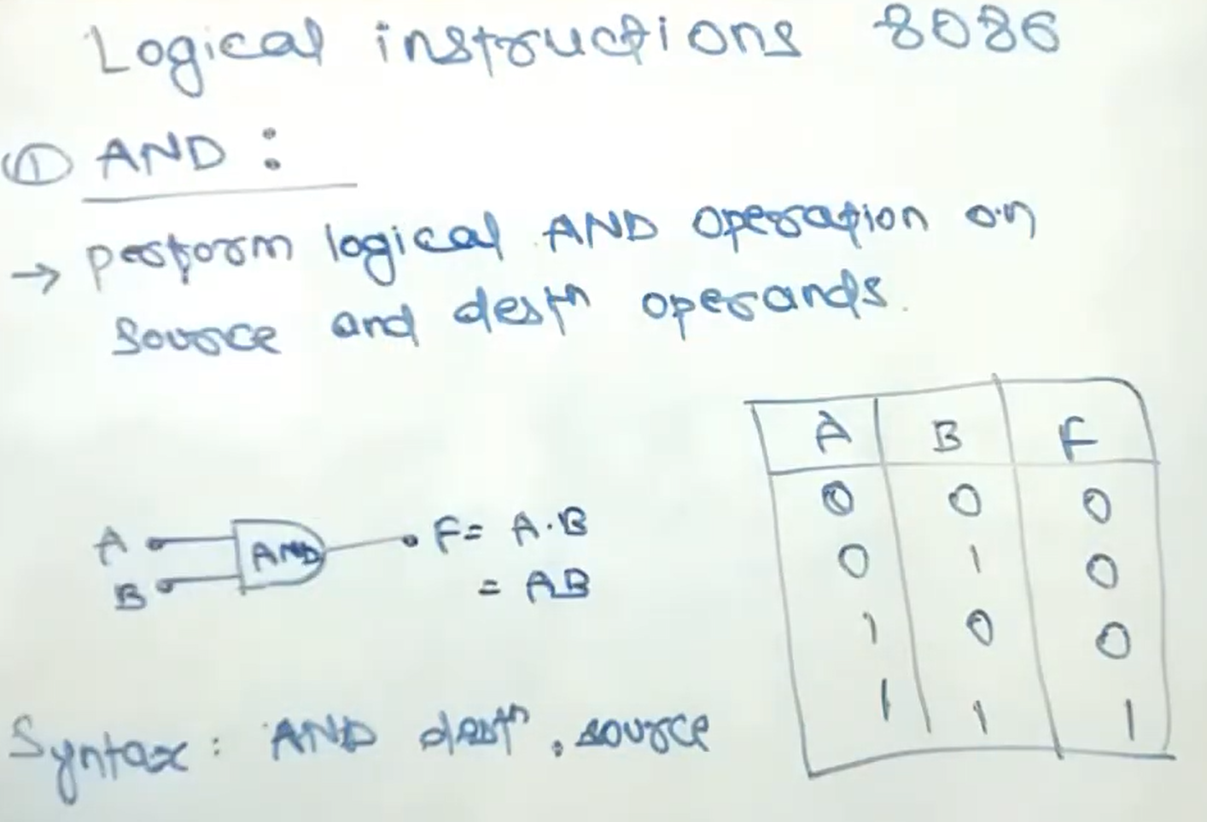

8086 & 8088:

We can set memory address or any register at **destination**, but we cannot set any immediate value at destination. We can set immediate value, memory address, or any register at source.

The four basic operations are AND, OR, XOR, and NOT (byte or word).

The important thing about these operations is that they are bitwise. This means that if **“and ax, bx”** or **“and byte [mem], 5”** or **“and al, 05H”** instruction is given, then the operation of AND is applied on corresponding bits of AX and BX. There are **16 AND operations** as a result; one for every bit of AX. Bit 0 of AX will be set if both its original value and Bit 0 of BX are set.

AX = 0F95H

Total 16 bits:

|  |  |  |  |  |  |  |  |  |  |  |  |  |  |  |  |  |
| --- | --- | --- | --- | --- | --- | --- | --- | --- | --- | --- | --- | --- | --- | --- | --- | --- |
| Bit | 0 | 1 | 2 | 3 | 4 | 5 | 6 | 7 | 8 | 9 | 10 | 11 | 12 | 13 | 14 | 15 |
| AX | 0 | 0 | 0 | 0 | 1 | 1 | 1 | 1 | 1 | 0 | 0 | 1 | 0 | 1 | 0 | 1 |

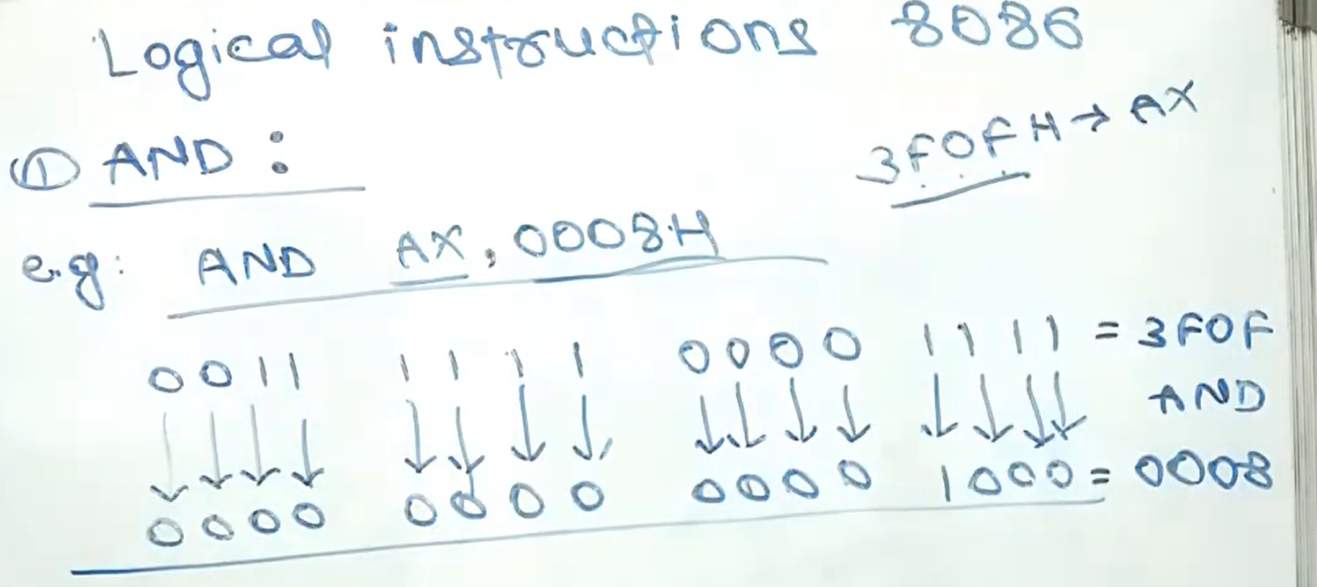

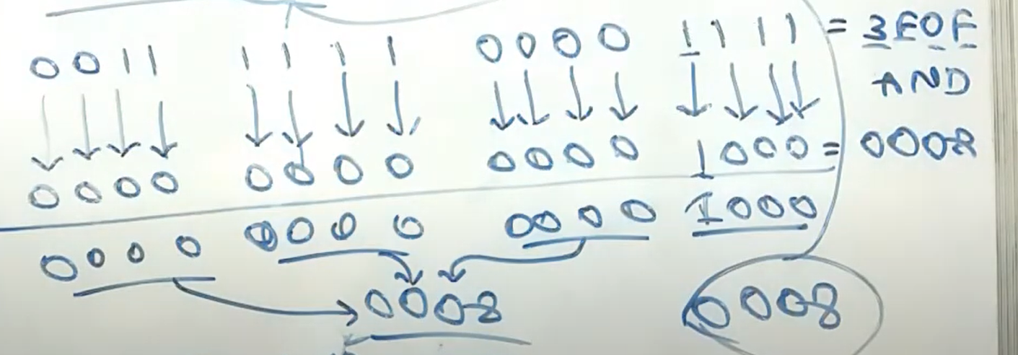

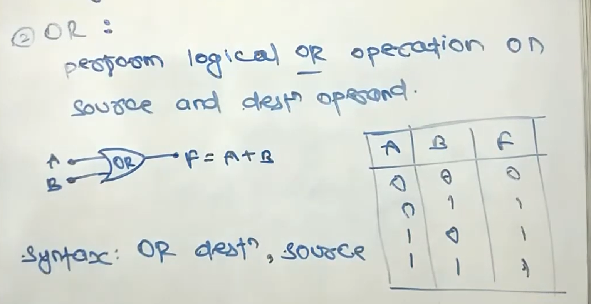

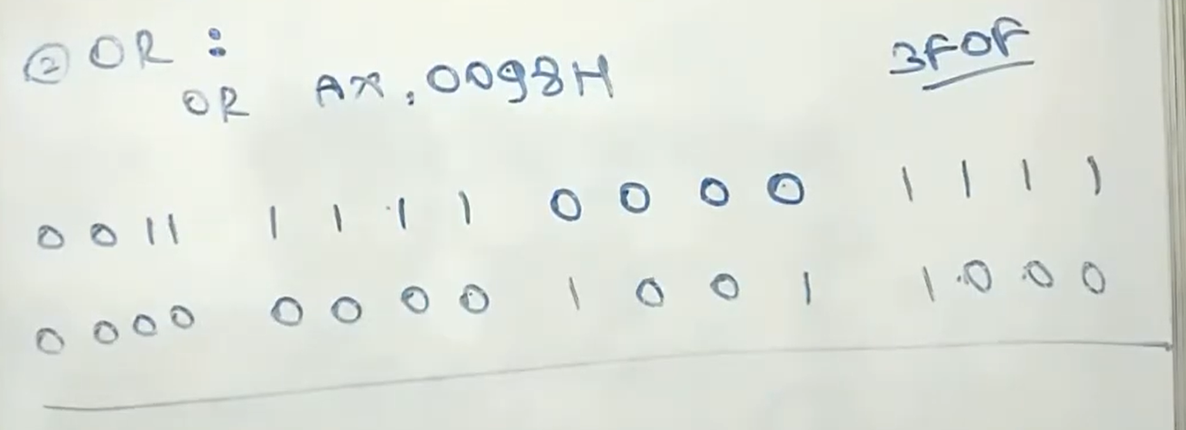

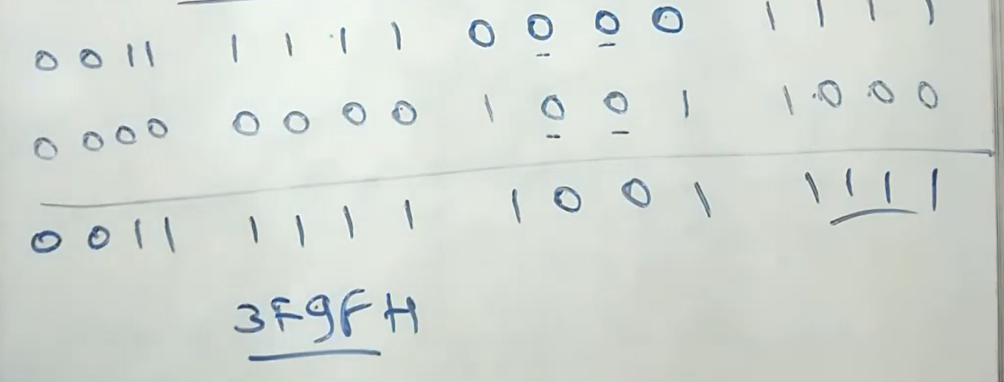

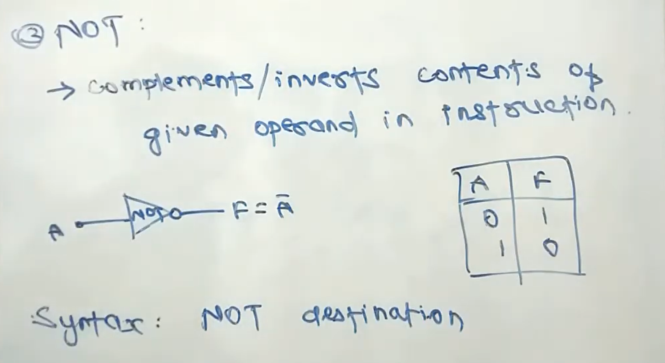

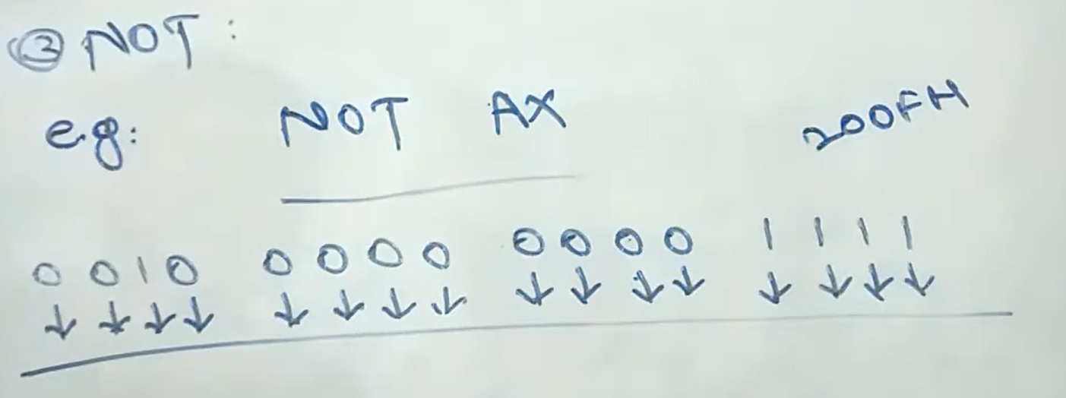

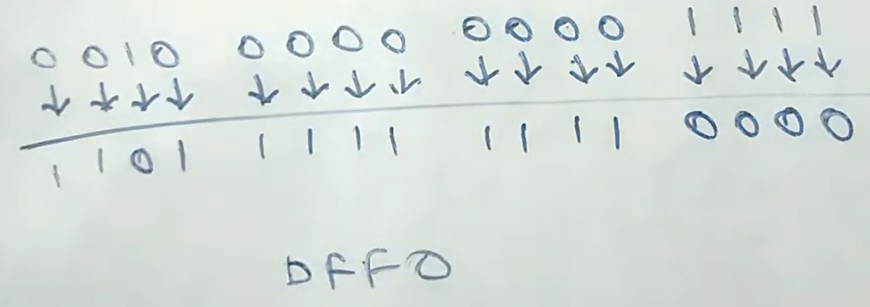

NOT (byte or word) [memory]

NOT ax

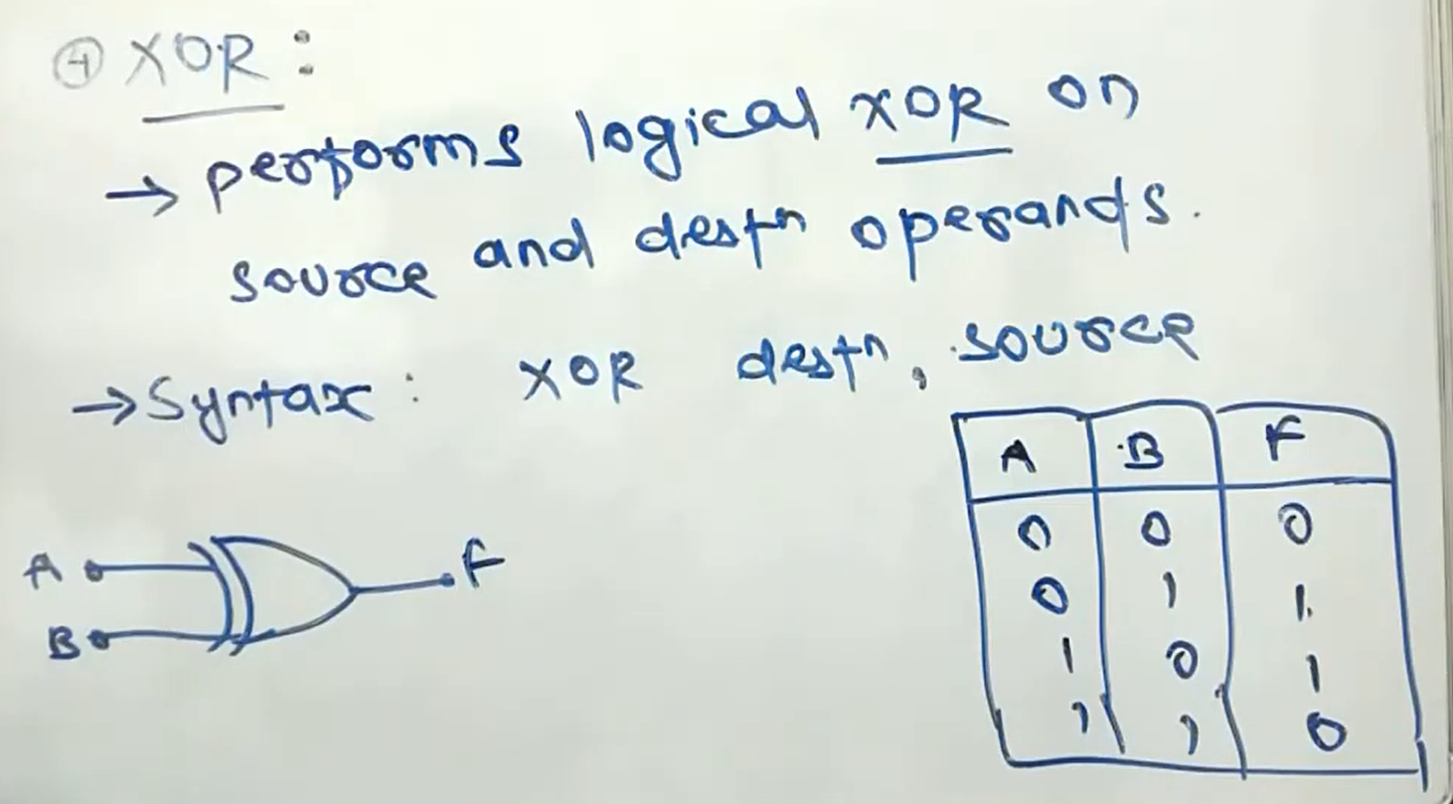

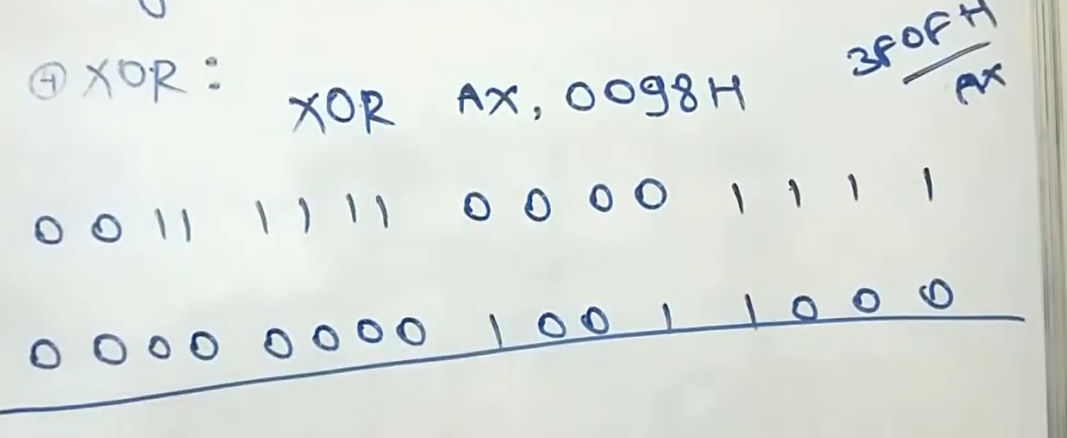

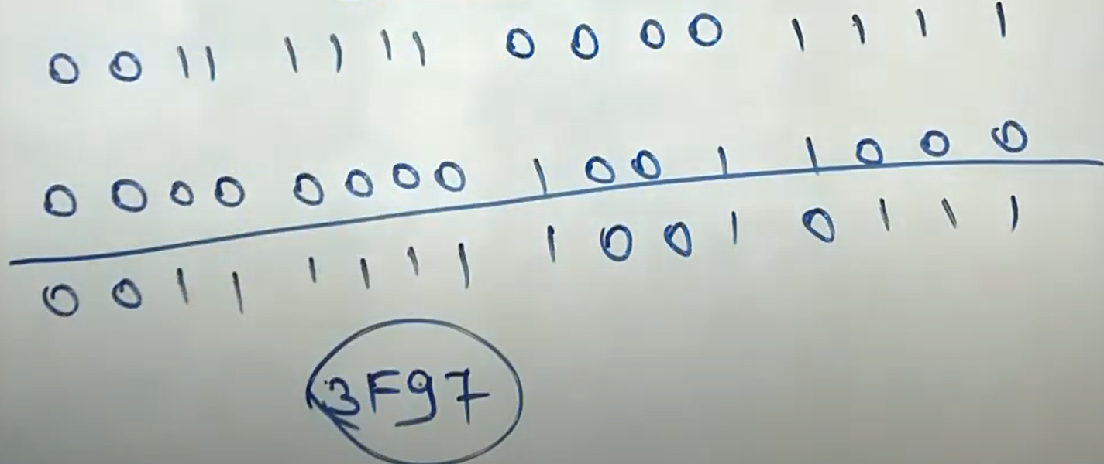

**XOR** is a very important operation due to the property that it is a **reversible operation**. It is used in many cryptography algorithms, image processing, and in drawing operations.

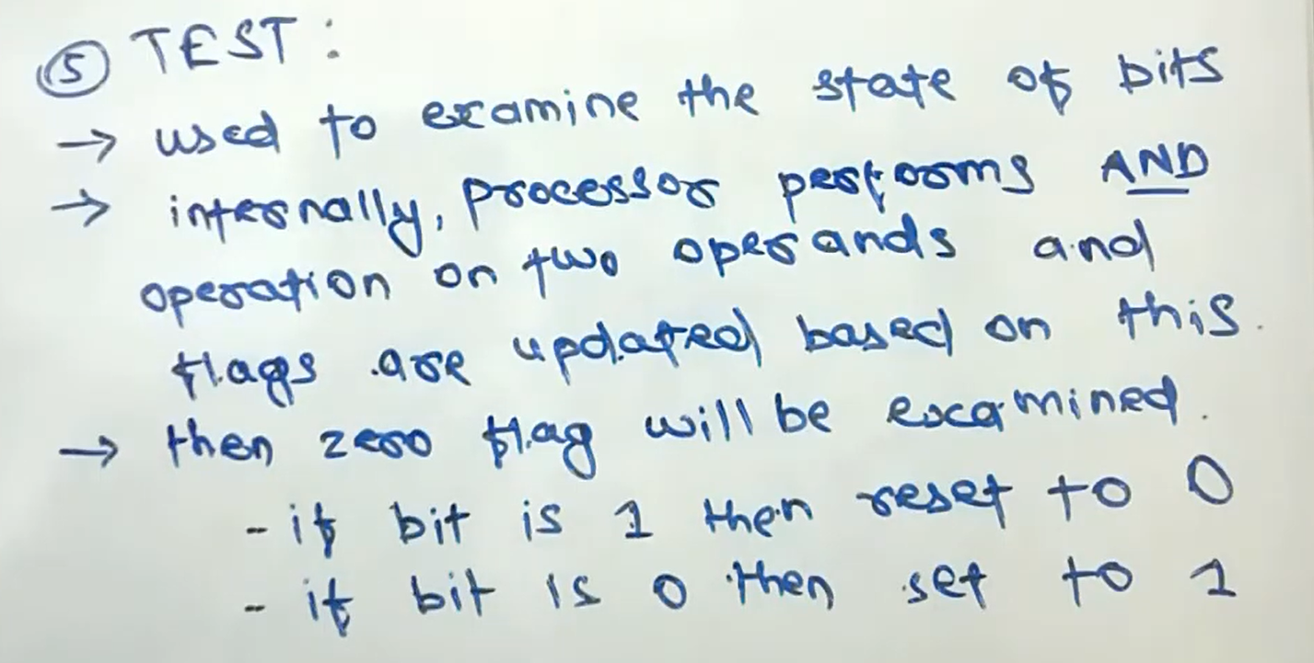

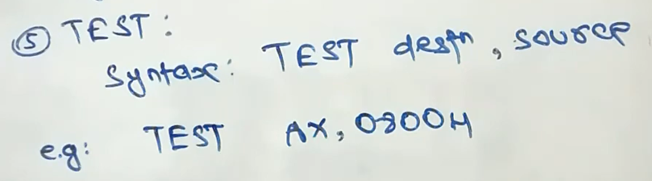

Write a program to swap every pair of bits in the AX register.

[org 0x0100]

jmp start

num: dw 1500

swap: dw 0

start: mov ax, [num]

mov bx, ax

mov cx, ax

and bx, 0x5555 ; Extract odd bits

and cx, 0xAAAA ; Extract even bits

shl bx, 1 ; Shift odd bits to even places

shr cx, 1 ; Shift even bits to odd places

mov ax, 0

or ax, cx

or ax, bx

mov [swap], ax

mov ax, 0x4c00

int 0x21